(First Author) Name Surname^{1*}, (Second Author) Name Surname²... (Times New Roman 10 italic – style – autori)

title is centered all caps TNR 11 bold 6 pt spacing after – style – heading 1)

Title translated into serbian

Originalni naučni rad / Original scientific paper
Rad primljen / Paper received:
https://doi.org/10.69644/ivk-xxxx-xx-xxxx
Adresa autora / Author's address:
¹⁾ Name of institution, xxxx-xxxx-xxxx-xxxx
*email: (email of contact author)
²⁾ Name of institution, xxxx-xxxx-xxxx-xxxx
³⁾ ... ... .../ ... ... ...

Keywords
- first keyword (TNR 10 pt, style – kljreci)
- second keyword
- .... .... ....
- .... .... ....
- .... .... ....
Abstract
The abstract may have one or more paragraphs in TNR 10 italic. The first paragraph line is indented by 0.4 cm.
Ključne reči
- prva ključna reč (TNR 10 pt, style – kljreci)
- druga ključna reč
- .... .... ....
- ... ... ....
- .... ..... .....
Izvod
Izvod je TNR 10 italic, jedan ili više paragrafa, koristiti raspored tastature Serbian Latin. Prvi red u paragrafu je uvučen 0,4 cm.

INTRODUCTION (heading 2, ALL CAPS TNR 10)
Text should be in two columns, 8.5 cm (3.35") each, with 0.6 cm (0.24") space between them, with the exception of certain figures and tables (see below).
Margins for all pages should be set to 2.7 cm (1.06") top and bottom, and 1.7 cm (0.67") left and right.
Use font TNR (Times New Roman) 10. The first line of each paragraph is indented by 0.4 cm (0.16").

Sub-chapters (heading 3 – TNR 10 italic)
The style – tekst from the template is already defined.
Equations can be centered or aligned to the left and their numbers are aligned to the right of column. For example:
(1)
This document template also has a pre-defined style – formula, with a paragraph spacing of 2 pt, before and after.
Equations are to be prepared with Word’s Equation Editor or by MathType. Parameters for equation typing are the size 10 pt TNR; subscripts and superscripts 8 pt, sub-subscripts are 8 pt. Numbers, parantheses and capital Greek symbols are not italic. All latin type variables A, B, X, Y, a, b, x, y as well as small Greek symbols α, β, γ, are italic, and the vector and matrice symbols Γ, A, X, are in TNR Bold. Operators i functions are also not italic, e.g.
(2)
Symbols of chemical elements and units of measure for physical quantities are also not italic.
(3)
Figures are centered and may take the space of both columns if it is necessary, (style style slika). The text on figures must be readable. Please use font sizes 9 pt on figures. This template example has a pre-defined style potpis slike for the figure captions of 9 pt TNR, and also the style potpis tabele for Table captions in TNR 9 pt. Figures and Tables must not be duplicated when the paper is presented in both Serbian and English. The text in Tables is TNR 9 pt, and is centered in table columns and uses the style tekst tabele. See examples below.
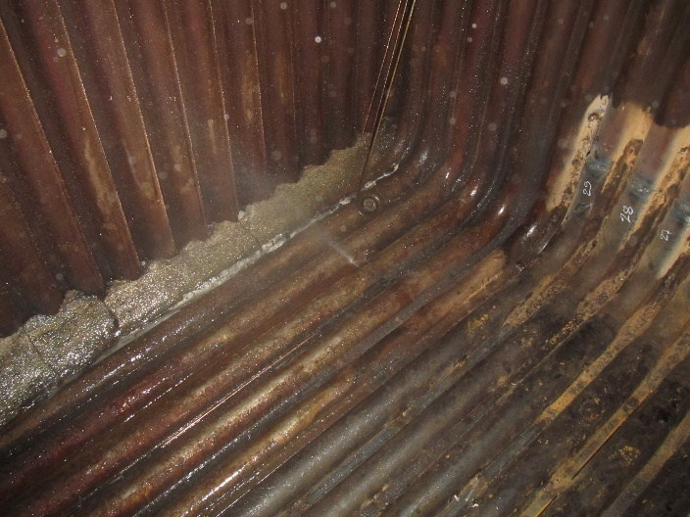
Figure 1. Example of a figure.
Table 1. Example of a table.
 |  | Large | Small
Surface crack |  | LSC | SSC
Crack depth | a | 2.5 | 1
Crack length | 2c | 8 | 8
Crack tip | r | 0.1 | 0.1
WM length |  | 2 | 2

Variables, e.g., α, γ, or Δ, Ω, δ with dimensions are given in paranthesis (°C), (μm), or e.g. [kNm]. Numbered values are followed by dimensions without paranthesis: 101.02 μm, 24.005 °C, or e.g. 2.2×10^{–5} MPa.
Literature or references are cited in the text by number in tilted parantheses, e.g. /1-3, 5, 7, 13/. List the References (or literature) at the end of paper in TNR 9 pt. Use automatic numbering with the given style literatura. See the example below.

REFERENCES (heading 2) style literatura
(Book titles)
- Sadd, M.H., Elasticity: Theory, Applications and Numerics, Academic Press, Elsevier, 2005.
- Suresh, S., Mortensen, A., Fundamentals of Functionally Graded Materials: Processing and Thermomechanical Behavior of Graded Metals and Metal-Ceramic Composites, London: IOM Comm. Ltd., 1998.
- Tzou, H.S., Piezoelectric Shells, Distributed Sensing and Control of Continua, (SMIA book series, vol.19), Kluwer Academic Publ., 1993. doi: 10.1007/978-94-011-1783-8

(Original book in written in a language other than English)
- Gol'Denveizer, A.L., Theory of Elastic Thin Shells, 2nd Ed. (in Russian), Nauka, Moscow, 1976.

(Chapter in a book)
- Ellyin, F. (1989), A criterion for fatigue under multiaxial fatigue failure, In: Biaxial and Multiaxial Fatigue, EGF 3, K.J. Miller, M.W. Brown (Eds.), MEP, London, 1989: 571-583.

(Journal papers)
- Gross, S., Abel, E.W. (2001), A finite element analysis of hollow stemmed hip prostheses as a means of reducing stress shielding of the femur, J Biomech. 34(8): 995-1003. doi: 10.1016/S0021-9290(01)00072-0
- Dai, T., Dai, H.L. (2017), Analysis of rotating FGMEE circular disk with variable thickness under thermal environment, Appl. Math. Modelling, 45(C): 900-924. doi: 10.1016/j.apm.2017.01.007
- Posavljak, S. (2009), Damages computation of aircraft engine disks, Struct. Integ. and Life, 9(2): 113-124.
- Klarin, M., Spasojević Brkić, V., Golubović, T., et al. (2016), Production cycle time reduction in low and medium-low-tech companies: a case study for Serbia, Tehnički vjesnik, 23(4): 1103-1108. doi: 10.17559/TV-20140715130015
- Guigui, P., Lambert, P., Lassale, B., Deburge, A. (1997), Long-term outcome at adjacent levels of lumbar arthrodesis (in French), Rev. Chir. Orthop. Reparatrice. Appar. Mot. 83(8): 685-696.

(Doctoral Thesis)
- Denoziere, G. Numerical modeling of a ligamentous lumbar motion segment, Doctoral diss., Georgia Institute of Technology, 2004.
- Polikeit, A., Finite element analyses of the lumbar spine: clinical applications, Inaugural-Dissertation, University of Bern, 2002.

(Doctoral Thesis, e.g. written in a language other than English)
- Foucat, D. (2003), Effets de la présence d’un grillage métallique au sein du ciment de scellement des cupules des prothèses totales de hanche, Etude mécanique et thermique, Thèse de doctorat, de l’Université Louis Pasteur, Strasbourg. https://publication-theses.unistra.fr/public/theses_doctorat/2003/FOUCAT_Dominique_2003.pdf
- Hadžalić, M., Razvoj algoritama za određivanje integriteta i vijeka trajanja strukturnih elemenata izvoznih postrojenja, (Development of algorithm for structural and life assessment of mine hoist components) (in Bosnian), PhD Thesis, University of Zenica, Faculty of Mechanical Engineering, Zenica, Bosnia and Herzegovina, 2018.
(Conference Proceedings paper)
- Read, D.T., McHenry, H.I., Postweld heat treatment criteria for repair welds, 5th IFMASS, ed. S. Sedmak, EMAS, UK, 1990, p. 235.
- Tanasković, D., Đorđević, B., Sedmak, S., et al. (2017), Repair welding of lower rails of A 30CrMoV9 steel transport beam and the conditions under which the welding procedure must be carried out, Proc. 5th Int. Sci. Conf. Adv. Mech. Eng. (ISCAME), Debrecen, Hungary, 2017, p. 548-555.
- Šijački Žeravčić, V., Bakić, G., Đukić, M., et al. (2012), Mismatched welded joints of X10CrMoVNb91 Steel - beneficial and nonbeneficial properties, Int. Conf. Power Plants 2012, Serb. Soc. Thermal Eng. 2012, Zlatibor, Serbia. (in Serbian)
- Tanasković, D., Đorđević, B., Tatić, U., et al. (2017), Repair welding of gear shafts of service rollers at Železara Smederevo, in Proc. 8th Int. Scientific Conf. IRMES 2017, Trebinje, Bosnia & Herzegovina, pp.365-370. ISBN 978-9940-527-53-2
- Arsić, D., Lazić, V., Aleksandrović, S., et al. (2016), Reparation of the fractured mandrel axle-shaft by welding, Advances and Trends in Engineering Sciences and Technologies II, M. Al Ali, P. Platko (Eds.), Proc. 2nd Int. Conf on Eng. Sci. Technol., 2016, High Tatras, Slovak Republic, CRC Press, London, pp. 105-110. doi: 10.1201/9781315393827
(Handbook, Guide, Manual, etc.)
- Abaqus/CAE Ver 6.9. (2007). User’s Manual. Hibbitt, Karlsson & Sorensen, Inc.
- OriginPro, 9.0, 2013, OriginLab Corp., Northampton, MA, USA
- ARAMIS GOM GmbH. www.gom.com
(Technical notes, Procedure workbook, etc.)
- Ramberg, W., Osgood, W., Description of stress-strain curves by three parameters, National Advisory Committee for Aeronautics, Washington DC, Technical Note (1943) 902.
- Zerbst, U., Schödel, M., Webster, S., Ainsworth, R.A., Fitness-for-Service Fracture Assessment of Structures Containing Cracks - A Workbook based on the European SINTAP/FITNET Procedure, Academic Press, 2007.
- Koçak, M., Webster, S., Janosch, J.J., et al., Fitness for Service Procedure (FITNET), Revision MK8, GKSS Research Center, 2008.
- SINTAP: Structural INTegrity Assessment Procedure for European Industry, Final Revision, EU Project BE 95-1462, BRITE- EURAM Programme, 1999.
- Pravilnik o tehničkim normativima pri prevozu ljudi i materijala oknima rudnika (Regulations on technical norms in people and material transport in mine shafts) (in Serbian), Tehnički propisi, Rudarstvo, Belgrade, 1986, pp.490-526.
- Dopunski rudarski projekat za izradu i rekonstrukciju dvoetažnog izvoznog koša i pripadajućih spojnih pribora na izvoznom oknu 'Raspotočje', RI Tuzla, 1984. (in Bosnian: Annex of mining project for construction and reconstruction of 2-deck conveyance cage and associated connecting components at shaft hoist 'Raspotočje’).
(Standards)
- ASTM D638-14, Standard Test Method for Tensile Properties of Plastics (Annual Book of ASTM Standards, Vol.08.01, ASTM, Philadelphia, USA, 2014).
- ASTM D7791-10, Standard Test Method for Uniaxial Fatigue Properties of Plastics, ASTM Standard, 2010.
(Internet links)
- https://www.researchgate.net/publication/339076099_Impact_of_small-scale_tree_planting_patterns_on_outdoor_cooling_and_thermal_comfort

