(First Author) Name Surname¹, (Second Author) Name Surname²... (Times New Roman 10 italic – style – autori)

title is centered all caps TNR 11 bold 6 pt spacing after – style – heading 1)

Originalni naučni rad / Original scientific paper
UDK /UDC:
Rad primljen / Paper received:
Adresa autora / Author's address:
¹⁾ Name of institution
²⁾ Name of institution
³⁾ ... ... .../ ... ... ...

Ključne reči
- prva ključna reč (TNR 10 pt, style – kljreci)
- druga ključna reč
- .... .... ....
- ... ... ....
- .... ..... .....

Izvod
Izvod je TNR 10 italic, jedan ili više paragrafa, koristiti raspored tastature Serbian Latin. Prvi red u paragrafu je uvučen 0,4 cm.

Keywords
- first keyword (TNR 10 pt, style – kljreci)
- second keyword
- .... .... ....
- .... .... ....
- .... .... ....

Abstract
The abstract may have one or more paragraphs in TNR 10 italic. The first paragraph line is indented by 0.4 cm.

INTRODUCTION (heading 2, ALL CAPS TNR 10)
Text should be in two columns, 8.5 cm (3.35") each, with 0.6 cm (0.24") space between them, with the exception of certain figures and tables (see below).
Margins for all pages should be set to 2.7 cm (1.06") top and bottom, and 1.7 cm (0.67") left and right.
Use font TNR (Times New Roman) 10. The first line of each paragraph is indented by 0.4 cm (0.16").

Sub-chapters (heading 3 – TNR 10 italic)
The style – tekst from the template is already defined.
Equations can be centered or aligned to the left and their numbers are aligned to the right of column. For example:
(1)
This document template also has a pre-defined style – formula, with a paragraph spacing of 2 pt, before and after.
Equations are to be prepared with Word’s Equation Editor or by MathType. Parameters for equation typing are the size 10 pt TNR; subscripts and superscripts 8 pt, sub-subscripts are 8 pt. Numbers, parantheses and capital Greek symbols are not italic. All latin type variables A, B, X, Y, a, b, x, y as well as small Greek symbols α, β, γ, are italic, and the vector and matrice symbols Γ, A, X, are in TNR Bold. Operators i functions are also not italic, e.g.
(2)
Symbols of chemical elements and units of measure for physical quantities are also not italic.
(3)
Figures are centered and may take the space of both columns if it is necessary, (style style slika). The text on figures must be readable. Please use font sizes 9 pt on figures. This template example has a pre-defined style potpis slike for the figure captions of 9 pt TNR, and also the style potpis tabele for Table captions in TNR 9 pt. Figures and Tables must not be duplicated when the paper is presented in both Serbian and English. The text in Tables is TNR 9 pt, and is centered in table columns and uses the style tekst tabele. See examples below.
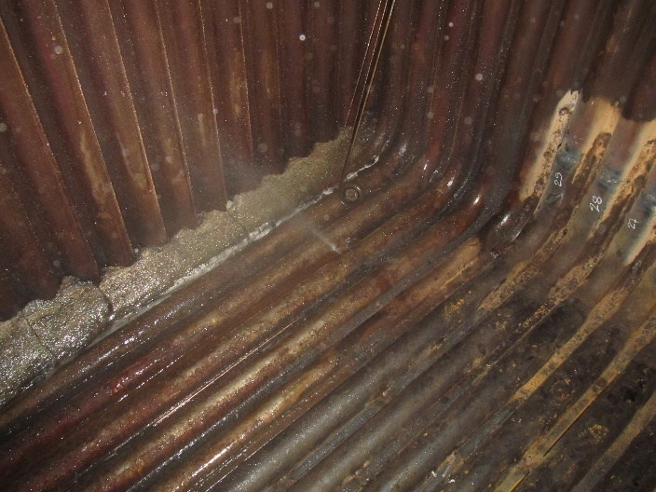
Figure 1. Example of a figure
Table 1. Example of a table
 |  | Large | Small
Surface crack |  | LSC | SSC
Crack depth | a | 2.5 | 1
Crack length | 2c | 8 | 8
Crack tip | r | 0.1 | 0.1
WM length |  | 2 | 2

Literature or references are cited in the text by number in large parantheses, e.g. [1-3,5,7,13]. List the References (or literature) at the end of paper in TNR 9 pt. Use automatic numbering with the style literatura. See the example below.

REFERENCES (heading 2)
- Essamei, M.A., Doctoral thesis, Faculty of Mechanical Engineering, University of Belgrade. (2000)
- Read, D.T., McHenry, H.I., Postweld heat treatment criteria for repair welds, 5th IFMASS, ed. S. Sedmak, EMAS, UK, 1990, p. 235. (style literatura)

